**MESD LMS Documentation – View all students enrolled into a teacher’s class or subject**

**Purpose**

To be able to view all students enrolled into a teacher’s class or subject.

**Background**

This module handles requests directly from Educators within the Moodle system, allowing functionality to view all students enrolled into that Educator’s class or subject.

**Usage**

**View students enrolled into a class or course/subject**

1. Login as an Educator.
2. Go to ‘*Home*’.
3. Click on the course to want to view.
4. Go to ‘*Participants*’.

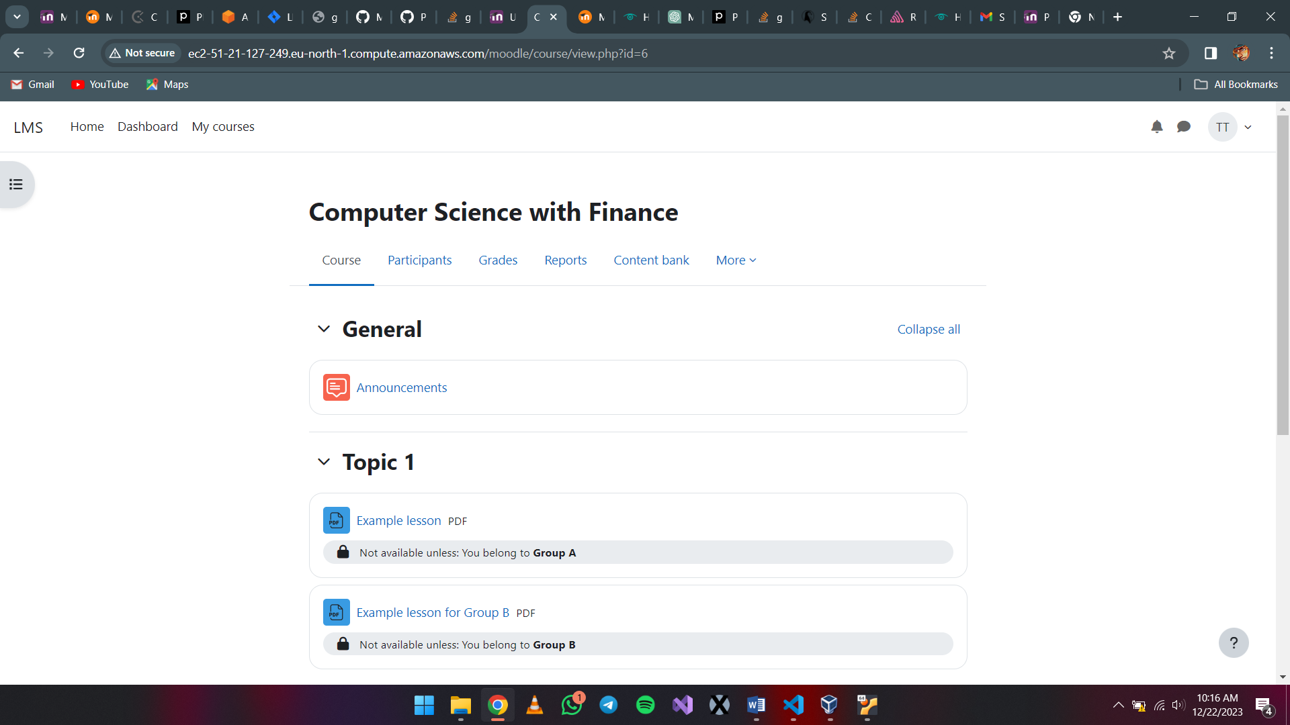

1. Go to *‘Add condition’.* Select ‘Roles’ under the drop down. Then select ‘Learner’ under the following dropdown.

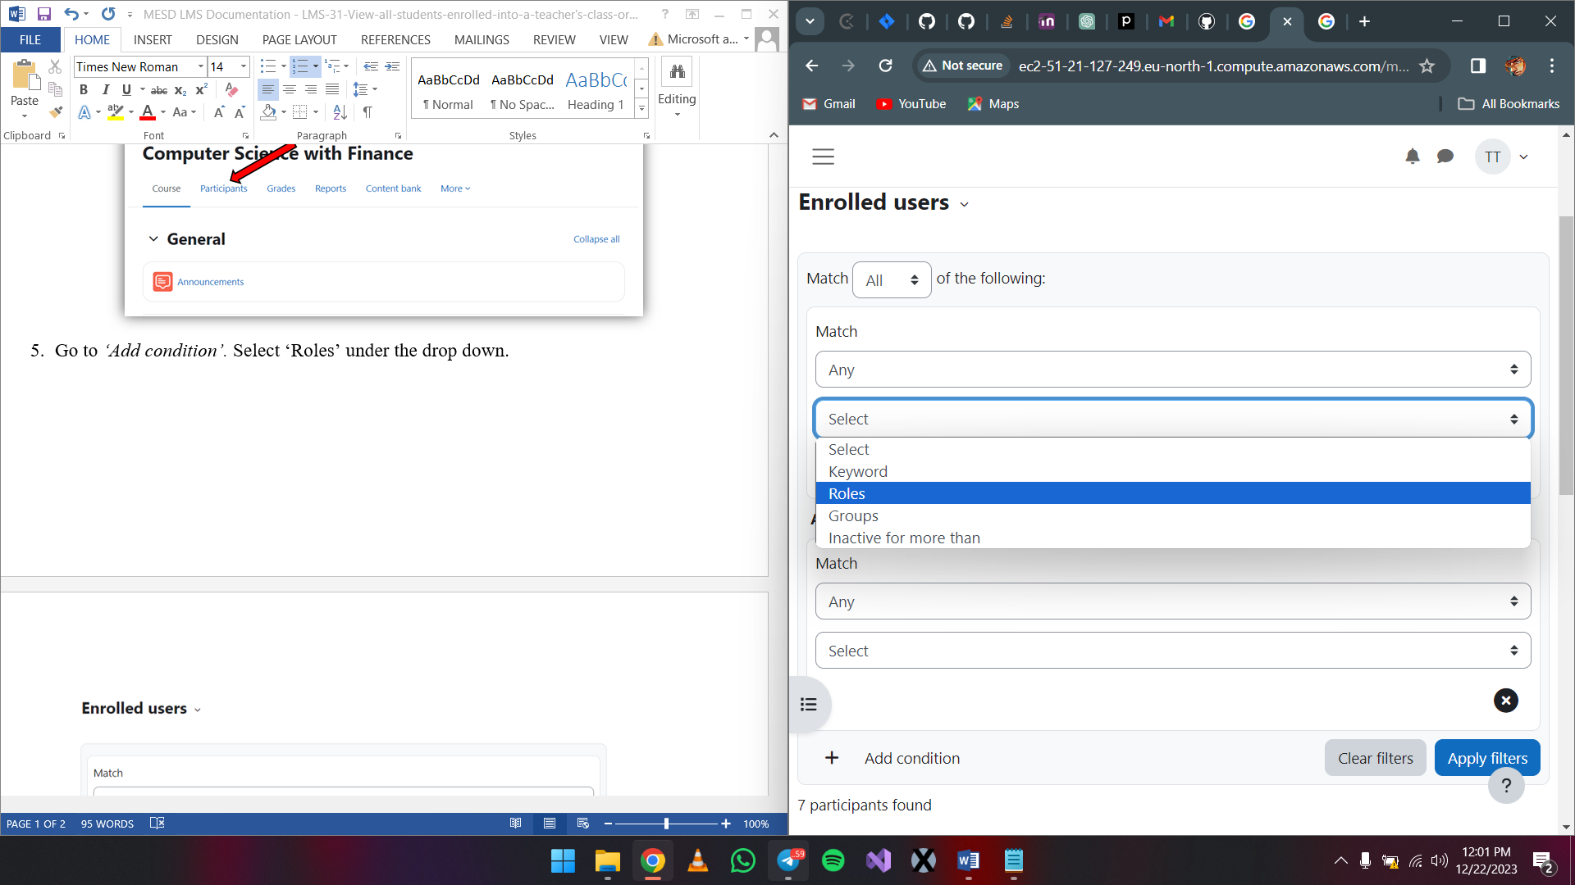

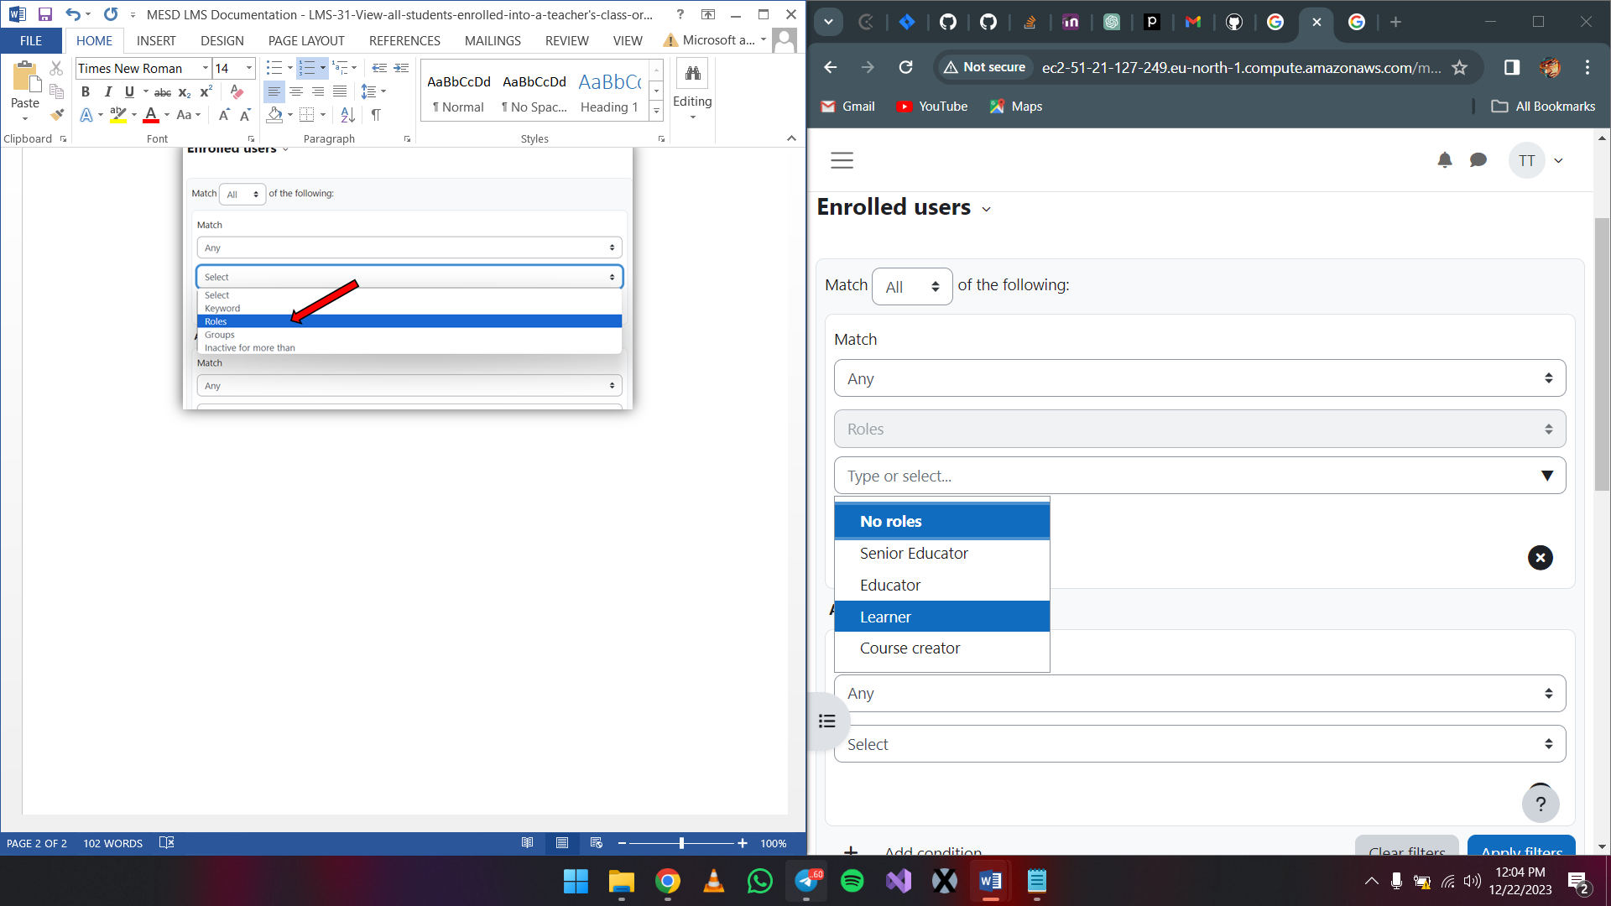

1. Click on *‘Apply filters’.* From here you will be able to see every student enrolled into a course.

